# PX logo replace instructions

The PX boot logo is divided into two parts, which can be combined in two ways: 1 .Static picture + Static picture. 2. Static picture + Animation.

## Replace the first static logo

The first logo of PX model is 4K, and the specific replacement steps are as follows:

1. File name of static logo: “bootup.bmp” (the specific image format is 4K resolution BMP RGB565 16bit,no more than 20MB).
2. Put “bootup.bmp” in the root directory of the USB disk.
3. Press "INPUT" on the remote control to enter the signal source selection interface. In this interface, the remote control continuously inputs "2", "4", "6" and "8" to enter the service menu, enter "OS settings" and find the item of "Change logo" for replacement.

## Replace the second static logo

1. File name of static logo: “bootImage.png” (4K resolution).
2. Put “bootImage.png” in the root directory of the USB disk.
3. Press "INPUT" on the remote control to enter the signal source selection interface. In this interface, the remote control continuously inputs "2", "4", "6" and "8" to enter the service menu, enter "OS settings" and find the item of "Change logo" for replacement.

## Replace the second animation

The second animated logo supports three formats: zip package, TS format video and MP4 format video. Details are as follows:

### Zip package

The essence of zip package is to put continuous pictures in folders and compress them into zip. Therefore, there is no sound. If you need to bring sound, you should make another sound file according to the requirements of Android. In the folder, you can store JPG format pictures and PNG format picture (PNG format picture needs to be set to 24 bit depth, otherwise it cannot be played). This method is suitable for simple boot animation. Complex boot animation will lead to too large zip file size. The specific replacement steps are as follows:

1. File name of animation logo: “bootanimation.zip”.
2. Put “bootanimation.zip” in the root directory of the USB disk.
3. Press "INPUT" on the remote control to enter the signal source selection interface. In this interface, the remote control continuously inputs "2", "4", "6" and "8" to enter the service menu, enter "OS settings" and find the item of "Change logo" for replacement.

“bootanimation.zip” is made according to the Android standard. The following is an example:

1. Create “part0”, “part1” directories.



1. Store multiple pictures in the “part0” directory and number them according to the playing order.

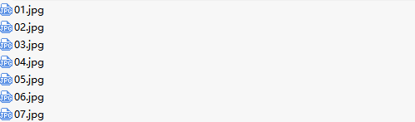

Store the last picture in “part1”



1. Write a description document named "desc.txt", which reads as follows:

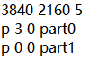

"3840 2160" indicates the display resolution. "5" means five pictures per second. "p 3 0 part0" means that after playing the pictures in the part0 directory 3 times in numbered order, the next directory will be played at an interval of 0 seconds. "p 3 0 part0" means that the pictures in the part1 directory are played circularly according to the numbering order (the first “0” means that the circularly playing is completed until the boot is completed).

NOTE: write different desc.txt to achieve different playback effects.

1. Store as zip file

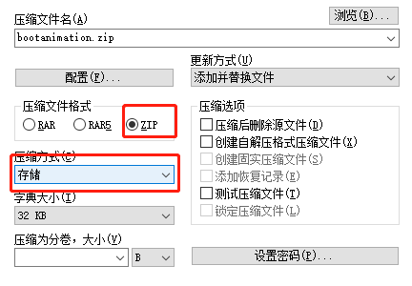

NOTE: compressed file format: zip, compression mode: storage.

The compressed directory is as follows:

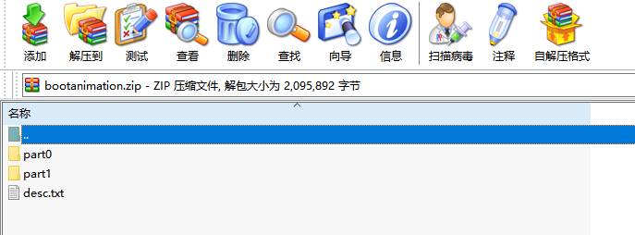

### TS format video

1. File name of animation logo: “video.ts”.
2. Put “video.ts” in the root directory of the USB disk.
3. Press "INPUT" on the remote control to enter the signal source selection interface. In this interface, the remote control continuously inputs "2", "4", "6" and "8" to enter the service menu, enter "OS settings" and find the item of "Change logo" for replacement.

### MP4 format video

1. File name of animation logo: “video.mp4”.
2. Put “video.mp4” in the root directory of the USB disk.
3. Press "INPUT" on the remote control to enter the signal source selection interface. In this interface, the remote control continuously inputs "2", "4", "6" and "8" to enter the service menu, enter "OS settings" and find the item of "Change logo" for replacement.

NOTE: the two parts of logo can be replaced separately or at the same time. Put the logo to be replaced in the root directory of the USB flash disk, press "INPUT" on the remote control to enter the signal source selection interface. In this interface, the remote control continuously inputs "2", "4", "6" and "8" to enter the service menu, enter "OS settings" and find the item of "change logo" for replacement.